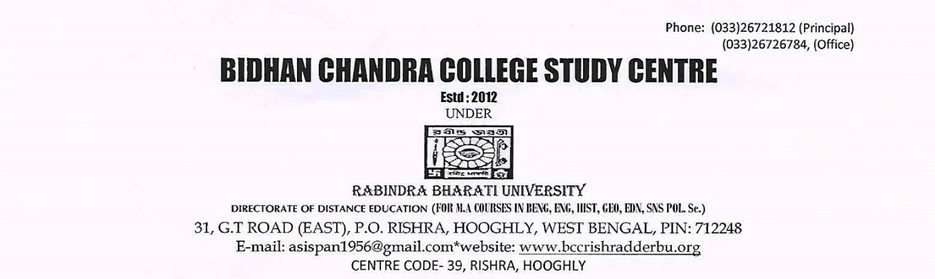

NOTICE

M.A. Part – II Examinees of 2016 are hereby informed that their Mark Sheet of M.A. Part – II ( English, Education) will be issued on 12/07/2017 (Wednesday) at 2 P.M. &
Mark Sheet of M.A. Part – II (History) will be issued on 16/07/2017 (Sunday) at 2 P.M.

By Order
Co-Ordinator
RBU,DDE,STUDY CENTER (39)
Rishra, Hooghly.

